**Executive Summary**

**Team-7**

The VP Operations at MediCrystals has engaged our team to enhance three crucial areas within the organization. Initially, the Procurement and Sourcing team leader learned from the CPO about the operational difficulties some essential suppliers are encountering due to the pandemic.

The goal is to establish an advanced risk assessment method to evaluate suppliers and assess the current mitigation measures. With the supplier data provided, the Risk Compliance Manager has identified two primary areas of risk: financial and regulatory. For the regulatory sector, the plan is to evaluate suppliers based on labor disputes and environmental issues.

Our task is to uncover additional risk domains and contributing factors, devise a detailed risk assessment framework, and pinpoint the suppliers that represent the highest risk.

Medi Crystals, a leading provider in the medical device industry, is committed to strengthening its Supplier Risk Management (SRM) to address potential disruptions caused by operational challenges faced by key suppliers. This document proposes a systematic approach to risk assessment aimed at identifying and prioritizing suppliers based on their risk profiles.

**High-level risk scoring methodology:**

To develop a high-level risk-scoring methodology for MediCrystals, a comprehensive evaluation of the supplier data was conducted, focusing on various risk dimensions. The first step was to create a pairwise comparison matrix for each risk factor, allowing for a systematic and quantitative assessment of each supplier against all others.

Using the Analytic Hierarchy Process (AHP), which is a structured technique for organizing and analyzing complex decisions, each supplier was evaluated relative to others based on criteria such as financial stability, operational efficiency, and regulatory compliance.

The evaluations were derived from supplier data such as revenue, cash from operations, and credit rating.

From these pairwise comparisons, the relative weights of each supplier were calculated, reflecting their respective risk levels. This enabled us to assign a numerical score that encapsulates the supplier's potential risk to MediCrystals’ operations.

With a sum of weighted scores, suppliers were ranked, and those with the highest cumulative scores were deemed to pose the most significant risk.

This methodology provided a clear and data-driven approach to identify which suppliers warrant closer scrutiny and potential risk mitigation activities.

These scores and rankings will inform the risk management strategy, guiding MediCrystals in reviewing current mitigation activities and establishing more robust risk management practices. This structured approach ensures

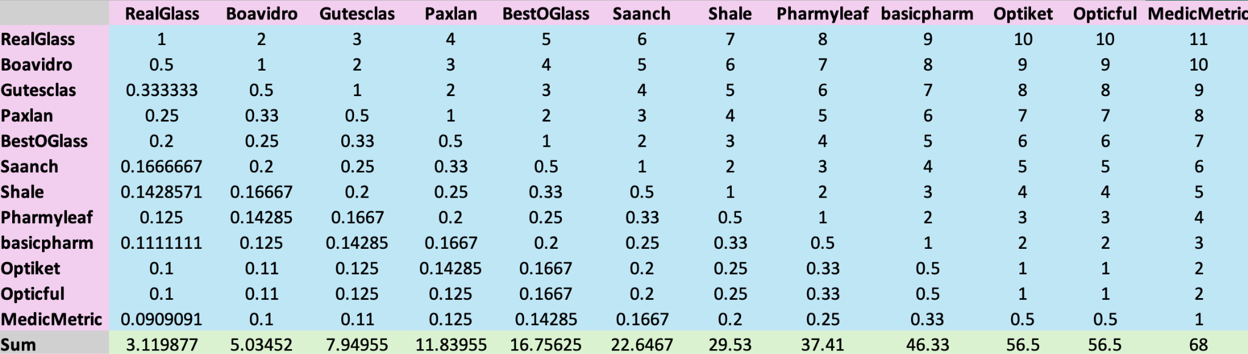

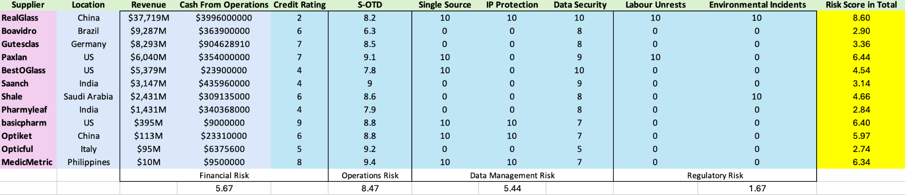

**Other Potential Risk Domains and Factors:**

1. *Operational Risk:*

* Supply chain interruptions
* Workforce shortages
* Issues with quality control

2. *Cybersecurity Risk:*

* History of data breaches
* Security certifications
* Capability for incident response

3. *Reputational Risk:*

* Violations of ethics
* Failure to comply with environmental regulations
* Adverse publicity

4. *Geopolitical Risk:*

* Political instability
* Environmental calamities
* Trade disputes

**Risk Scoring and Identification:**

Through the collection and analysis of data from diverse sources, we identify patterns, trends, and potential risk indicators related to suppliers. Each risk factor is assigned a score that reflects its severity and the supplier’s historical performance. Suppliers are then categorized into low, medium, and high risk based on their total scores calculated through weighted averages.

**Mitigation Activities:**

Mitigation strategies are tailored for suppliers identified as high risk. These strategies encompass enhanced monitoring, periodic supplier assessments, risk-sharing agreements, and diversifying the supply chain. As the business environment and supplier landscape evolve, continuous monitoring and reevaluation of supplier risk profiles and mitigation strategies are essential.

**Conclusion:**

The proposed risk-scoring method provides a robust framework for identifying, classifying, and mitigating supplier risks. By adopting proactive strategies to address these risks, MediCrystals can safeguard its operational integrity, uphold its reputation, and ensure compliance with industry standards.